Name: 1: ______________________ Name 2: ___________________________ Name 3: ___________________________ Name 4:______________________
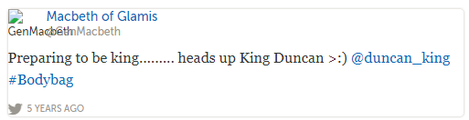
Tweeting Themes
Theme Chosen: | Colloquial Translation of Theme: | Summary of event which reflects the theme: | Supporting Lines/Dialogue (Must give two, speaker and lines!)
