How to Set Up: Turnitin.com
We will be using Turnitin.com to submit certain assignments this year. This is a part of the School Improvement Plan and many English teachers use this website (so get used to it). You must be enrolled in a class to submit papers, access grades, or access peer review assignments. You can self-enroll by creating a user profile using the class ID number and class enrollment password.
Step 1: Creating an Account
- Go to turnitin.com and click Create Account in the top right corner. Enter your email and a password and then click Student at the bottom.
- Enter the Class ID and Class Enrollment Password by looking at the chart below. It is based on your period number. Enter your first and last name, your password again, create security questions and agree to the terms.
****Use this information to enroll in the class. It is based on your class period with me.

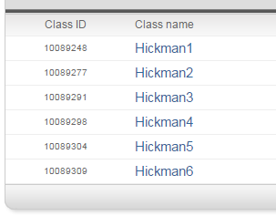
Class Enrollment Password

1st Period
2nd Period
3rd Period
4th Period
5th Period
6th Period

Step 3: Submitting
- After you click sign in, click on class name
- Find the assignment and click Submit
- Since you saved this assignment as a word document, you need to upload from the Hickman folder
- On the submit page, it must read Single File Upload for you to upload the finished assignment
- Upload the assignment, then confirm and submit.
- You should get an email confirmation email if the assignment was submitted properly

