Station Two – Primary Document
Till’s murder was seen in Jet magazine. Read the article below and answer the following questions
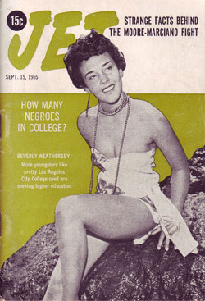

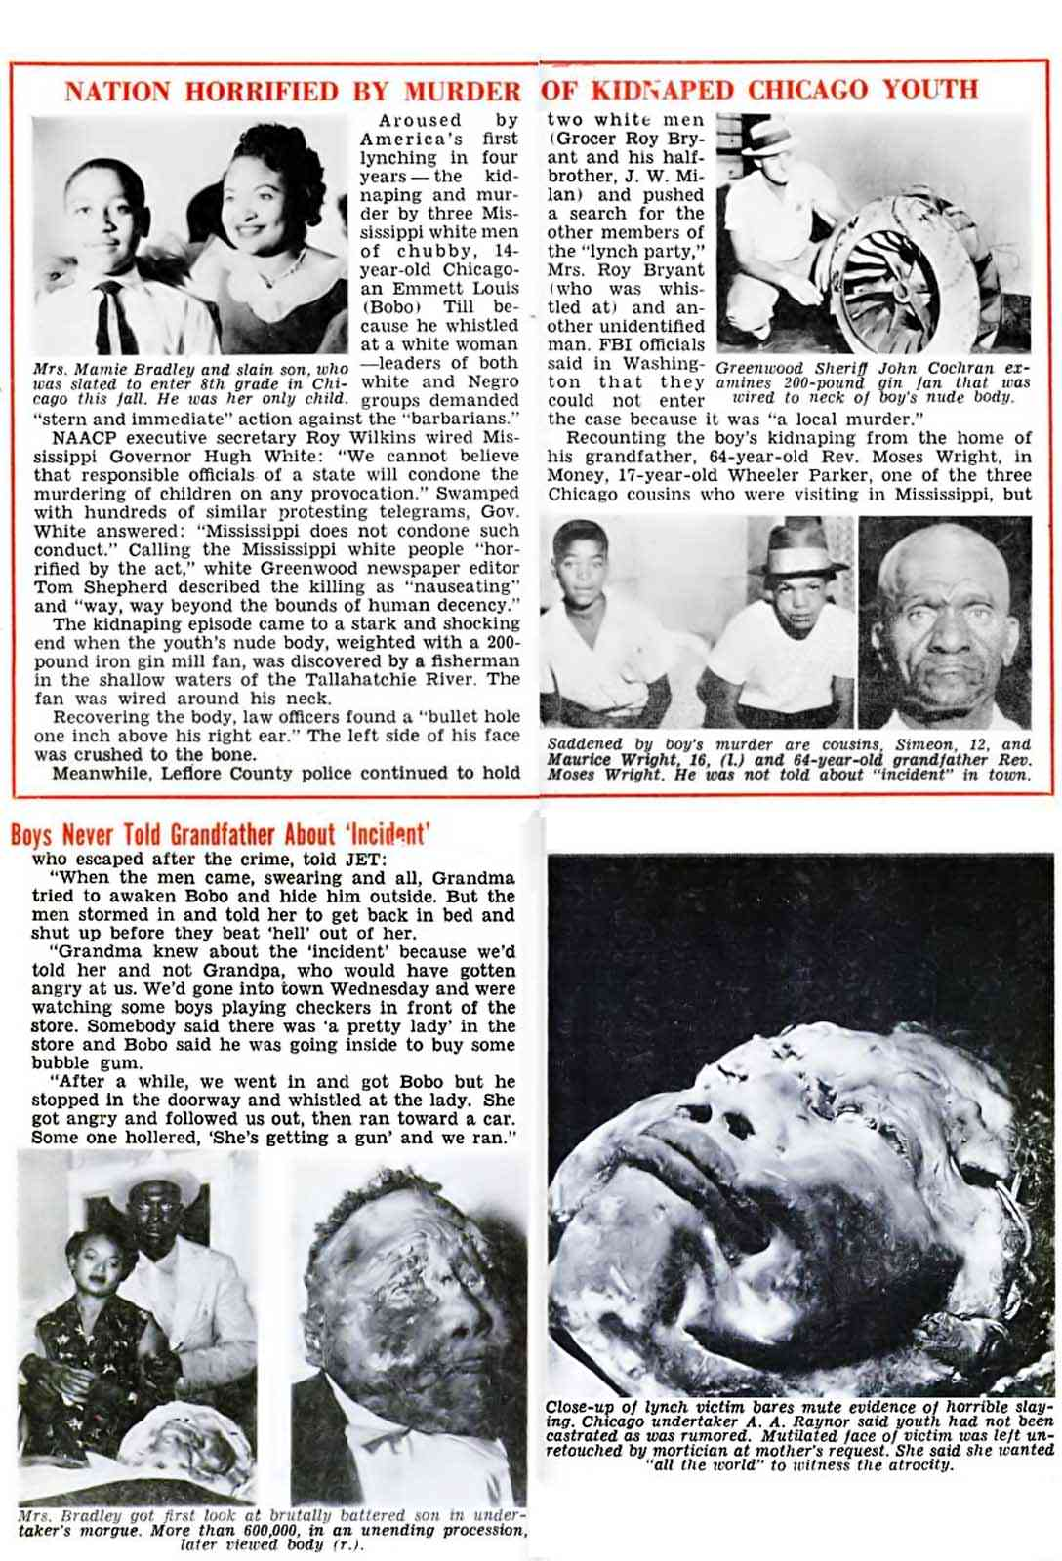
Station Three: Symbol Analysis

Directions: Below is a picture of Lady Justice, the symbol of the U.S.’s court system. Answer the following questions below.
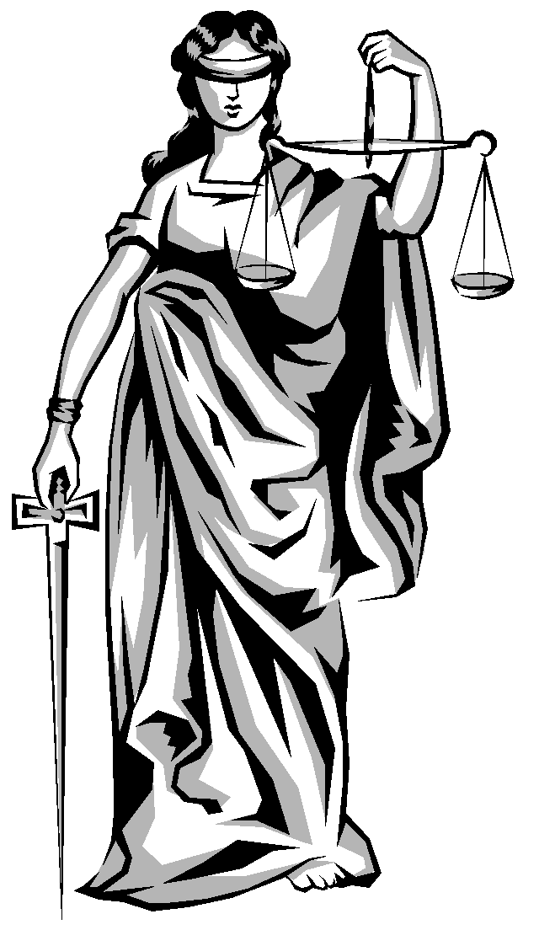
1. What is around Lady Justice’s face? Why do you think it is there?

2. What is Lady Justice carrying in her right hand? What do you think this symbolizes?

3. What is Lady Justice carrying in her left hand? What do you think this symbolizes.

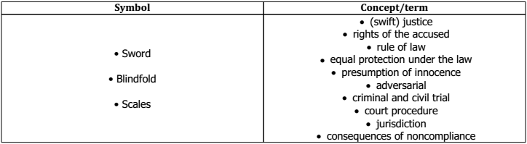
4. Match the symbol to a following term/concept.

Station Four: Bias/Parallel Case Study – Trayvon Martin
George Zimmerman Case: The Shooting of Trayvon Martin

Timeline of the Case:

Trayvon Benjamin Martin, born February 5, 1995, was a 17-year-old African-American high school student who lived in Miami Gardens, Florida with his mother Sybrina Fulton.

George Michael Zimmerman, born October 5, 1983, was a part-time student at Seminole State College and a neighborhood watch captain at the Retreat at Twin Lakes gated community in Sanford at the time of the shooting.
Timeline:
February 26, 2012 - George Zimmerman, a neighborhood watch captain in Sanford, Florida, calls 911 to report "a suspicious person" in the neighborhood. He is instructed not to get out of his SUV or approach the person. Zimmerman disregards the instructions. Moments later, neighbors report hearing gunfire. Zimmerman acknowledges that he shot Martin, claiming it was in self-defense. In a police report, Officer Timothy Smith writes that Zimmerman was bleeding from the nose and back of the head.
March 12, 2012 - Sanford Police Chief Bill Lee says that Zimmerman has not been charged because there are no grounds to disprove his story of the events.
March 13, 2012 - Sanford Police Department's homicide detective Christopher Serino recommends Zimmerman be charged with manslaughter.
March 15, 2012 - In a letter to the Orlando Sentinel, Robert Zimmerman, George Zimmerman's father, writes that George has been unfairly portrayed as a racist, and that George is Hispanic and grew up in a multiracial family.
March 16, 2012 - Authorities release seven 911 calls from the night of the shooting. In one of the 911 recordings, Zimmerman, against the advice of the 911 dispatcher, follows Martin. In one of the recordings, a voice screams "Help, help!" in the background, followed by the sound of a gunshot.
April 11, 2012 - Zimmerman is charged with second-degree murder. His new lawyer, Mark O'Mara, tells CNN that Zimmerman has turned himself in.
April 20, 2012 - Zimmerman's bond hearing is held. Judge Lester sets Zimmerman's bond at $150,000. During the hearing, Zimmerman apologizes to the family of Trayvon Martin for the loss of their son.
April 23, 2012 - Zimmerman is released on bail at 12:05 AM. Later in the day, Zimmerman enters a written not guilty plea and waves his right to appear at his arraignment.
July 13, 2013 - The six woman jury finds George Zimmerman not guilty. They had three choices: to find Zimmerman guilty of second-degree murder; to find him guilty of the lesser charge of manslaughter; or to find him not guilty. The jurors deliberated for more than 16 hours total, including 13 on Saturday alone.

Fear and the George Zimmerman Trial
Published by Fox News, July 2, 2013
There has been a lot of discussion in the news media about the fact that the George Zimmerman trial is really a story of white on black (white man with a gun, black victim).
One or both men were afraid for their lives. But who was afraid the most? This is in fact the greatest mystery.
Was it Zimmerman, on the bottom of the scrape, having his head pounded, fearing for his life as he maintains, or was it actually the now forever-silent Martin, fearing for his?
Which story is true in this case?
We may never know. But there are clues.
The striking photographs of an injured Zimmerman has been used at trial to suggest that he was badly beaten, but I must tell you that they don’t look that way to me nor to Dr. Michael Baden, one the top forensic pathologists in the U.S.
I discussed the photos with Dr. Baden and he agreed that the wounds “appear superficial.”
The scalp is very vascular and bleeds easily, making a cut look worse than it is. The same is true for the nose, and the fact that Zimmerman’s was bloodied doesn’t imply that he was hit hard.
The EMTs’ testimony that Zimmerman was able to answer questions at the scene and was able to stand and walk to the squad car and declined to go to the hospital also go against there having been significant injury.
There appears to be a growing body of evidence that George Zimmerman wasn’t badly hurt by Trayvon Martin, which is not the same thing as saying he wasn’t afraid of him.

Article 2
Article 1

Zimmerman Medical Report Shows Broken Nose, Lacerations After Trayvon Martin Shooting

ABC News, May 15, 2012

A medical report compiled by the family physician of Trayvon Martin shooter George Zimmerman and obtained exclusively by ABC News found that Zimmerman was diagnosed with a "closed fracture" of his nose, a pair of black eyes, two lacerations to the back of his head and a minor back injury the day after he fatally shot Martin during an alleged altercation.
Zimmerman faces a second degree murder charge for the Feb. 26 shooting that left the unarmed 17-year-old high school junior dead. Zimmerman has claimed self defense in what he described as a life and death struggle that Martin initiated by accosting him, punching him in the face, then repeatedly bashing his head into the pavement.
Zimmerman's three-page medical report is included in those documents that the defense could use as evidence.
The morning after the shooting, on Feb. 27, Zimmerman sought treatment at the offices of a general physician at a family practice near Sanford, Fla.
The record shows that Zimmerman also suffered bruising in the upper lip and cheek and lower back pain. The two lacerations on the back of his head, one of them nearly an inch long, the other about a quarter-inch long. The injuries seem to be enough for Zimmerman to claim self-defense for killing Trayvon Martin

Station Four Guiding Questions: Timeline of the Case
Directions: Using the documents, answer the questions below in complete sentences.
- In a letter to the Orlando Sentinel on March 15, Robert Zimmerman claimed the media had been biased against his son. Explain in one sentence what Robert Zimmerman claimed was the bias against his son.

- In reading the Timeline of the Case, do you think this timeline (which came from CNN) is fact-based or opinion-based? Meaning, is it biased? Explain in one sentence why you think it is or is not.

Activity Two Guiding Questions: Article 1
- In reading Document 1, what injuries does it claim Zimmerman suffered on the night of Trayvon Martin’s death?

- What tone does the author have about Zimmerman’s injuries? Meaning how does the author feel about the injuries? Are they serious or insignificant?

- Pick out one phrase or sentence in Document 1 which proves the author’s tone.

- Do you believe the author is biased for George Zimmerman or biased against him? Write one sentence explaining your reasoning.

Activity Two: Guiding Questions: Article 2
- In reading Document 2, what injuries does it claim Zimmerman suffered on the night of Trayvon Martin’s death?

- What tone does the author have about Zimmerman’s injuries? Meaning how does the author feel about the injuries? Are they serious or insignificant?

- Pick out one phrase or sentence in Document 2 which proves the author’s tone.

- Do you believe the author is biased for George Zimmerman or biased against him? Write one sentence explaining your reasoning.
Station Five: Political Cartoon Analysis
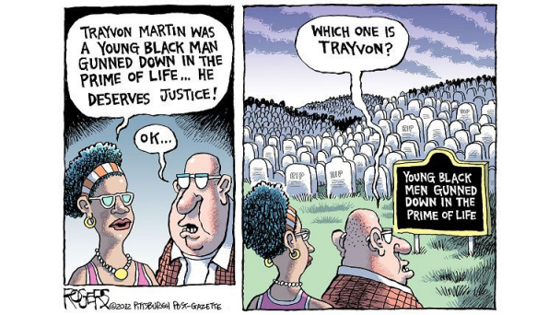

- Looking at the cartoon, would the man speaking support George Zimmerman’s claim of self-defense or not? WHY?

- Who are the people in the cemetery?

- What message do you think the author is trying to present to the reader in this cartoon in regards to this issue?

