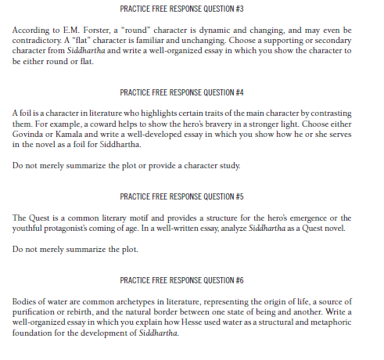

This constructed response:
- Needs to follow the format of a constructed response.
- Is missing the title and author of the text.
- Needs a clear thesis statement that answers/addresses the prompt.
- Needs to define terms in the prompt and/or summarize the plot/main idea of the text.
- Needs to use transitions and introduce quotes.
- Is missing quotes/evidence that relate directly to the thesis statement.
- Is missing thorough explanations/elaboration that relates back to the thesis statement.
- Needs a restated thesis that ties all the information together and is not the same as the original thesis.
- Needs to be corrected for grammatical and mechanical errors.
__________________________________________________________________________________________________________________________________________________________________________________________________________________________________________________________________________________________________________________________________________________________________________________________________________________________________________________________________________________________________________________________________________________________________
__________________________________________________________________________________________________________________________________________________________________________________________________________________________________________________________________________________________________________________________________________________________________________________________________________________________________________________________________________________________________________________________________________________________________
__________________________________________________________________________________________________________________________________________________________________________________________________________________________________________________________________________________________________________________________________________________________________________________________________________________________________________________________________________________________________________________________________________________________________
________________________________________________________________________________________________________________________________________________________________________________________________________________________________________________________________________________________________________________________________________________________________________________________________________________________________________________________________________________________________________________________________________________________________________________________________________________________________________________________________________________________________________________________________________________________________________________________________________________________________________________________________________________________________________________________________________________________________________________________________________________________________________________________________________________________________________________________________________________________________________________________________________________________________________________________________________________________________________________________________________________________________________________________________________________________________________________________________________________________________________________
__________________________________________________________________________________________________________________________________________________________________________________________________________________________________________________________________________________________________________________________________________________________________________________________________________________________________________________________________________________________________________________________________________________________________
__________________________________________________________________________________________________________________________________________________________________________________________________________________________________________________________________________________________________________________________________________________________________________________________________________________________________________________________________________________________________________________________________________________________________
__________________________________________________________________________________________________________________________________________________________________________________________________________________________________________________________________________________________________________________________________________________________________________________________________________________________________________________________________________________________________________________________________________________________________
_____________________________________________________________________________________________________________________________________________________________________________________________________________________________________________________________________________________________________________________________________________________________________________________________________________________________________________________________________________________________________________________________________________________________________________________________________________________________________________________________________________________________________________________________________________________________________________________________________________________________________________________________________________________________________________________________________________________________________________________________________________________________________________________________________________________________________________________________________________________________________________________________________________________________________________________________________________________________________________________________________________________________________________________________________________________

