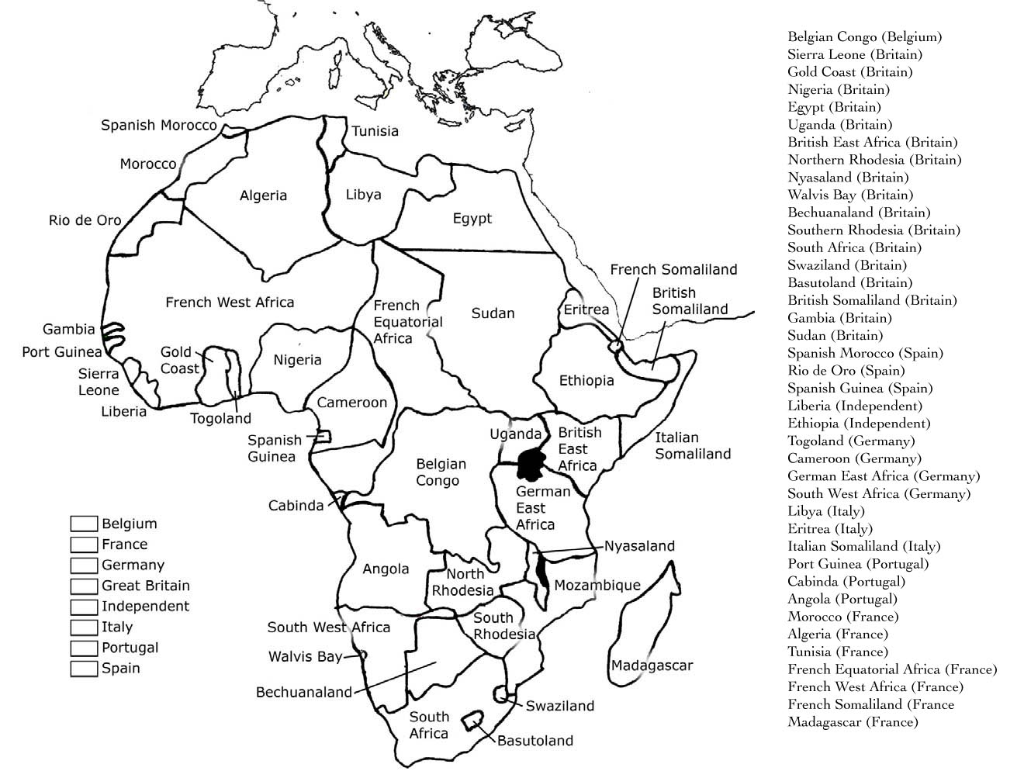
Name: _____________________________ Date: ___________________
Scramble for Africa
Directions: Color code the empires that colonized Africa. Make sure to complete the key.

