Night Test Review Sheet 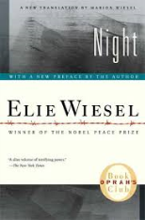

Please review the following characters:
Elie’s father (Chlomo Wiesel) Madame Schacher
Moche the Beadle Juliek
Tzipora Idek
Franek Dr. Mengele

Please review the following unit 1 terms:
denotation conflict
theme setting
style connotation
voice plot
imagery narrative

Please be sure to review the following literary terms:
Anaphora Understatement
Metaphor Oxymoron
Irony Hyperbole
Simile Onomatopoeia

Please review the following German/Jewish specific terms:
Final Solution
Anti-Semitism
Auschwitz

Please review the specifics of each chapter also!!

Denotation
Theme
Style
Voice
Imagery
Conflict
Setting
Connotation
Plot
Narrative

