Name: ___________________________
Guided Notes for Research Presentation
- Plagiarism originates from the Latin word plagiarius, which means __________________, meaning literary thief.
- Plagiarism is keeping any of the same ________________ without quotations, even if cited. It is also keeping the original order of ideas or sentence ___________________ without quotations, even if cited (no _________ and __________ and using _______________.
- In the “real world”, plagiarism can cause you to be ___________ from college, __________ your job, lose ___________________ for another college or job, or be _____________ by the person’s ideas you borrowed.
- Instead of plagiarizing, you should use a ____________ quotation. Be sure to give the author’s ___________ when using a quotation.
- You can ______________________ if you do not want to use quotations. When you paraphrase, you should explain the __________ ideas of what you read, write completely in your ______ words, show that you _________________ the source, and ___________ the source.
- Before paraphrasing, you should ___________ after each paragraph and ask yourself what you just ________. Take _________ on your reading and write down main ____________. Don’t use complete _____________________.
- To paraphrase, put the ____________ away. Take notes in your __________ words.
- When you cite your sources, use the _________ and page # (if there is one) and put them in parenthesis. If there is no author, use the page ___________.
- If you use a quotation, be sure to put ___________ ___________ around the author’s words, and put a ______________ directly after the quote. Then, ______________ and ____________ your evidence in your own words.
- In addition to your internal citations, you must also create a ___________ ____________ page at the end of your paper listing each source you used.
- Parenthetical citations go within your paper right after the ________ or _________.
- If you forget how to use MLA properly, you can use _________________, MLA _____________, or ____________ generators like Easy Bib.
- When formatting your paper, make sure the entire paper is ___________ spaced, in _______ font, margins are set at _______ inch, and all paragraphs should be ______________. Also be sure to have a ___________ with _________ numbers in the upper right-hand corner. In the top left-hand corner, list your _____________, your teacher’s _________, the ______________, and the _____________. Be sure to also ___________ the paper’s title.
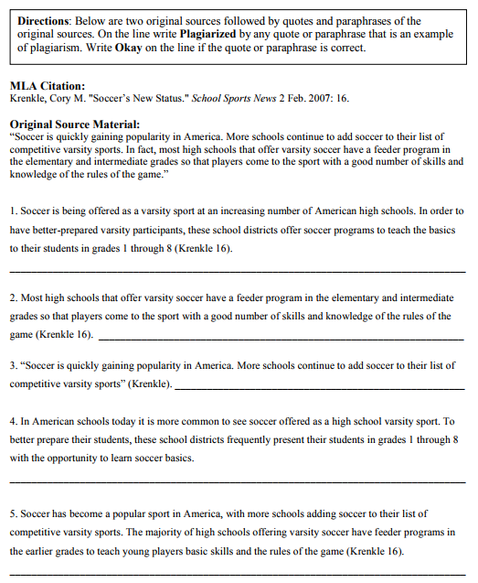

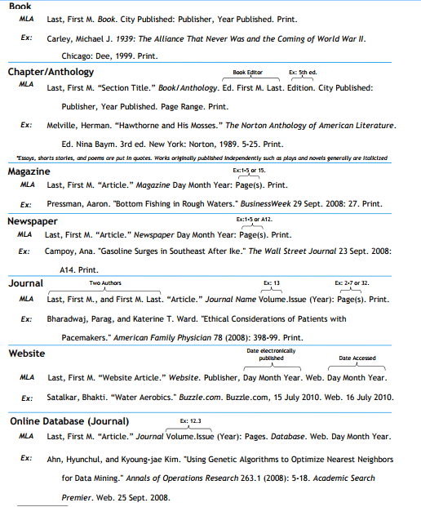

Works Cited Activity
Citation 1:
Citation 2:
Citation 3:
Citation 4:
Citation 5:

Discussion Questions
- Is the order always easy and obvious? Something you can memorize for each and every text format?

- What was one confusing piece you noticed?

- What can usually be found at the beginning of an MLA citation?

- What are some pieces of data that can be found at the end? Give two pieces.

- Why would some have two years?

- Do citation machines always get it right? What should you do?

https://tinyurl.com/yaml9rsz - MLA MasterBlaster Quiz - Take

