Name: _________________________ Date: ______________
Where I’m From Poem Cheat Sheet and Requirements
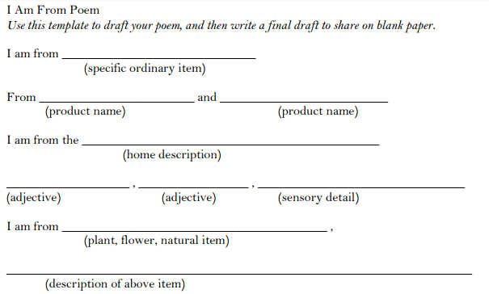
First Stanza Help

Model Poem
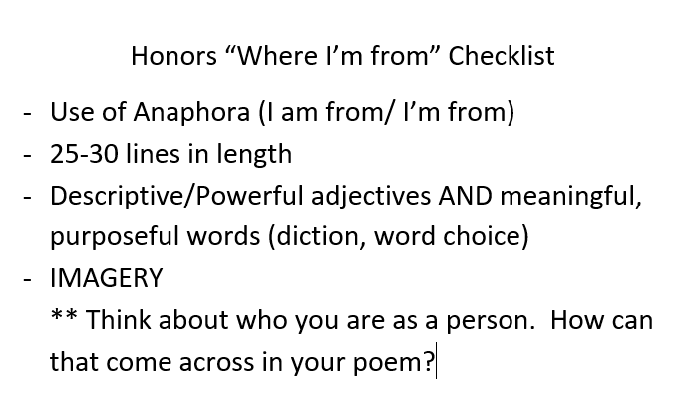
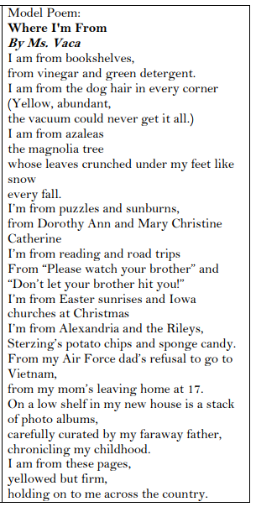
**** Note: Think about what the topics each stanza discusses to guide.

