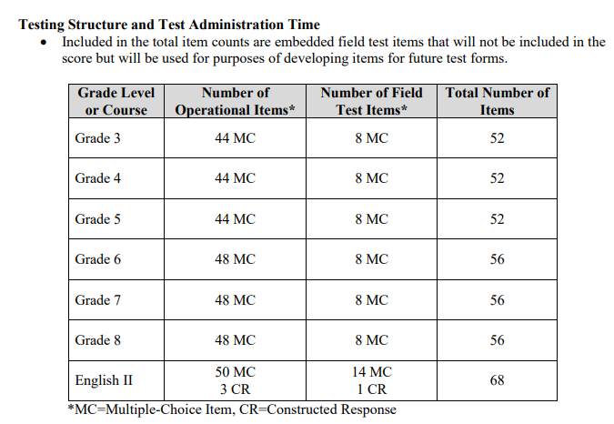
English II EOC Information

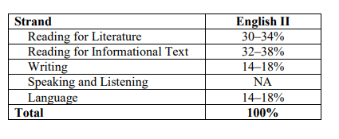

Hickman/Grimsley EOC English II Exam
- Eat something before this exam. It is almost twice as long as regular NCFE’s and teacher made exams.
- Arrive in Lab 971 NO LATER than 8:55 am.
- Your computer will already be assigned and the exam intro page will already be pulled up.
- Bookbags will go into a corner
- No food or drinks
- Bring a book for underneath your desk. You can not play on the computer when finished, so your options are to read the book you brought or put your head down.
- You get scratch paper, so bring a pencil
- You have to hand over your phone
- You can not enter once testing begins, there is nothing to pass out because the test is online. Once I read directions, you click start. So, if you are late, you risk having to come for a make-up day.
- The testing time is 160 minutes but you will have up to 3.5 hours if you need it.
- Use the restroom if you need to go or not. With an exam this long, you may need a stretch break.

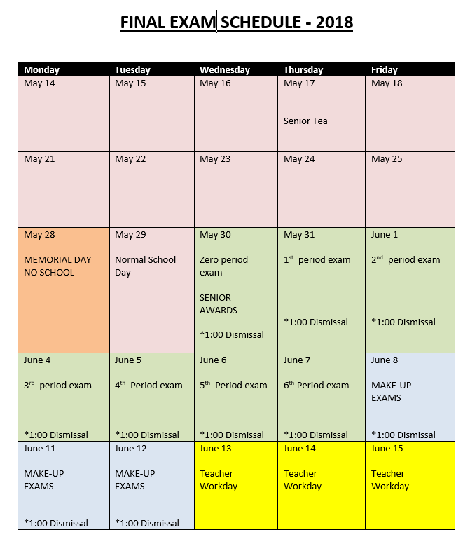

10 Failsafe Test-Taking Tips

Psych out your tests with these 10 simple tips
Posted Oct 08, 2011
Whether it's an entrance exam for college, grad school, law school, med school, or just an in-class quiz in college or high school, there are a few simple tools that psychology can offer you to help you maximize your performance.
Most people have difficulty with multiple-choice exams which force you into a definite right-or-wrong answer. This advice is best used for exams that have this format and are not administered on a computer.
1. Read the question and decide what it is asking.
Really read the question and figure out what you're being asked. Don't assume it's asking one thing but looking for something else, or that it's a trick question (a good test doesn't have trick questions). Try to match the question with the topics you've covered or reviewed, especially if you've been given hints in a review session or practice test.
2. Choose your answer before you read the choices.
If you can answer the question without having to look at the choices, then it's a safe assumption that you got that one right. When you do look at the choices, and your answer (or a choice similar to what you guessed) appears, that is probably the correct one.
3. Build up points (and your confidence).
Take advantage of the tried and true strategy of bootstrapping. If possible, answer the questions you're certain of and then go back and answer the ones you weren't so sure of when you first saw them. Tackling one question can give your memory a jog so you can answer questions on related topics. You may not be able to skip from question to question, so if you can't, you'll have to adopt some of the other strategies below. Whatever you do, don't get discouraged when you can't answer a question so that you can continue to think logically.
4. Leave blank the questions you're not sure about.
If possible, don't fill in your answer unless you're very sure. Instead, leave it blank and mark it as one you need to return to later. This gives you the opportunity to use bootstrapping, and avoids the likelihood of turning in the exam with an answer that you weren't very confident of.
5. Decide whether the answer makes sense in the sentence.
Narrow down your choices by ruling out answers that don't seem to fit into the flow of the question. A good test won't have this problem, but invariably, even good test writers slip once in a while. Also be very suspicious of choices that have "always" or "never" as these are rarely (but not never) correct.

6. Think about the "English" meaning of technical words.
Even if you don't know the exact meaning of a technical term, think about its common-sense meaning. Don't be confused if the answer seems too obvious because the same word was in the stem of the question. Sometimes test writers either deliberately or subconsciously plant these little hints.
7. Eliminate choices you know are wrong.
If you can write on the test paper, use it to your advantage. Cross out the obviously wrong choices. This way, the question is less confusing and cluttered and you can narrow the options down to two or three from four and or five. You've now increased your odds of getting it right from 0% to 40% or even 50%. Also, try to identify the gist of the choice (its meaning) by picking out one or two key words or phrases. Don't get lost in the wording of the choice. Sometimes one word makes the choice obviously wrong (or obviously right).

8. Don't second-guess yourself but don't rush to finish.
If an answer jumps out at you, it is probably correct, do not change it. However, in the event where you are stuck on a question, take your time. Think it through, use other questions to try to help you (BOOTSTRAPPING), move on and return to it later, etc. Do not feel rushed and don't worry that others around you may be finishing. You have more than enough time. If you need it, use it. According to the "first instinct fallacy(link is external)," most people remember when they changed a right to a wrong answer, but more times than not, people change the wrong to right ones ones after they've had a chance to think over the item more critically.
9. Use the context to help you retrieve.
When you come across a question on a topic you can't quite remember, think about where you were when you studied this topic or learned about it in the first place. Putting yourself mentally where you were when you learned the material might help you relive the experience, and the fact.
10. Keep up your self-efficacy.
The worst thing you can do is start to doubt your own test-taking ability. Move forward with confidence and don't think about how nervous you feel, how bad you're doing, or how much your loved ones and friends will feel let down if you don't do well. Test anxiety is one of the most detrimental emotions that people can feel during an exam because it leads them to focus on their unpleasant feelings rather than on the material.
In summary, you can do well on any test you take if you keep your wits about you. And to seal the deal, make sure that you study (but don't cram). Get a good night's sleep before any test. If you didn't do well, get feedback to help you do better next time. If necessary, change your study habits. Form a study group with others, especially people who do well on tests. When you do study, concentrate on what you're learning and turn off all your other sources of distraction such as music, TV, and online social media.

https://www.psychologytoday.com/us/blog/fulfillment-any-age/201110/10-failsafe-test-taking-tips

Questions: Psychology Today Article (Write in complete sentences)
- Read Tip #1; what should you not do?

- Before you review the choices, what should happen?

- Why should you skip answers you don’t know?

- If you know an answers is wrong, what should be happening?

- Read tip #8, what should you not worry about?

- When studying, what should be done with distractions?

- Using context clues, what do you think self-efficacy means?

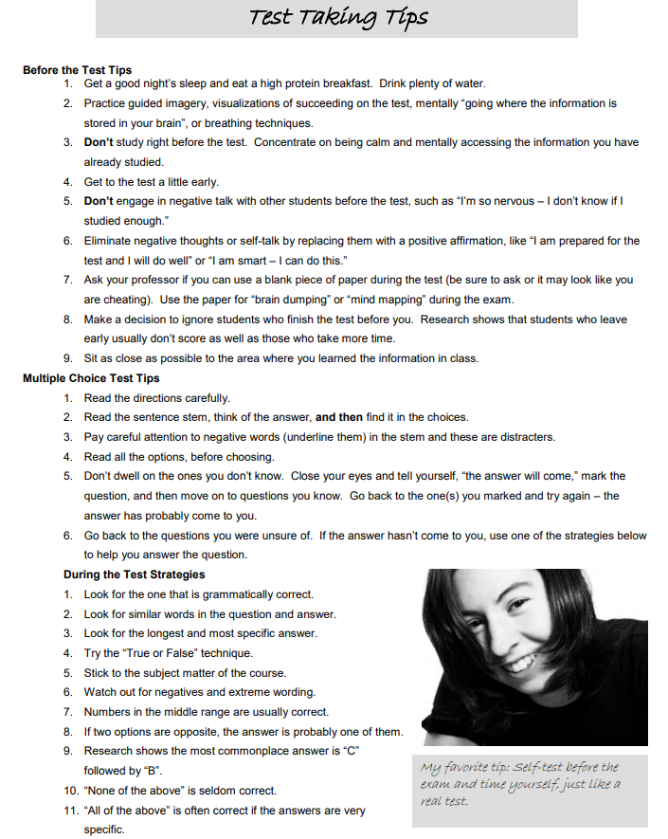

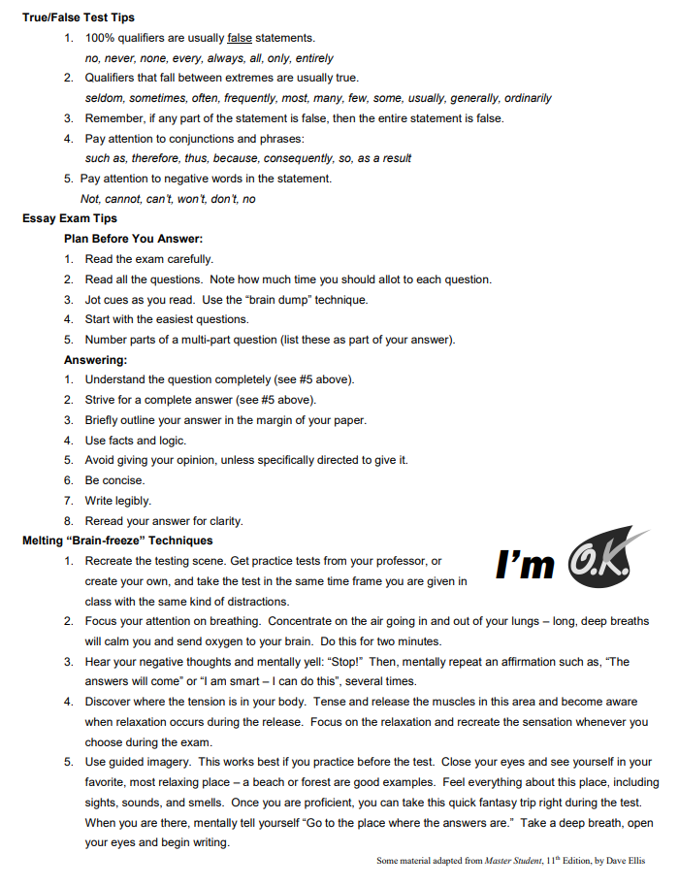

Test Taking Tips Questions
- Why should you not engage in negative talk before an exam?

- What does research show about students who chronically finish tests early?

- Why do you think you should look for similar wording?

- Watch out for what type of wording?

- What choice is often correct?

- What are the most commonplace answers?

- Why do you think 100% qualifiers are usually false statements?

- What is Guided Imagery and why should you use it?

