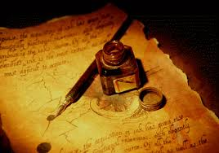
Response Book Guidelines

Summarizations
On the left hand side of your response book, include an image or a visual representation of the chapter or the topic addressed in your response. It could be a drawing or an image/artwork that you have researched, including an MLA citation. In 2-3 sentences, explain your image and its connection to the chapter/response.
Reflections
The right hand side of your log is for your responses regarding Night chapter response questions. Think critically of what you have read or viewed and respond to the best of your ability. Your responses should reflection critical thought as well as a personal connection to what has taken place. You may ask questions, provide an emotional retort, focus on one event that has impacted you in some way, discuss a significant change in a character, or compare and contrast Holocaust survivor experiences between the video and the memoir, Night. Most importantly, your response must be honest and mature.
Chapter & Video Entries
- 1st Entry-Chapter 1
- 2nd Entry-Chapter 2
- 3rd Entry-Chapter 3
- 4th Entry--“The Devil’s Arithmetic”
- 5th Entry-Chapter 4
- 6th Entry-Chapter 5
- 7th Entry-“One Survivor Remembers”
- 8th Entry-Chapter 6
- 9th Entry-Chapter 7
- 10th Entry--“Interview with Oprah Winfrey & Elie Wiesel
- 11th Entry-Chapter 8 and 9

Length

The length requirement is half a page or to the end of the page length in your booklet. If all your entries in your Response Book are written with critical thought you will not have a problem with length.

\Grammar & Neatness
Entries in your log can be typed and pasted or can be written. Make sure your entries are legible and neat. You will be graded on capitalization, spelling, and punctuation; therefore, all entries should be error free.
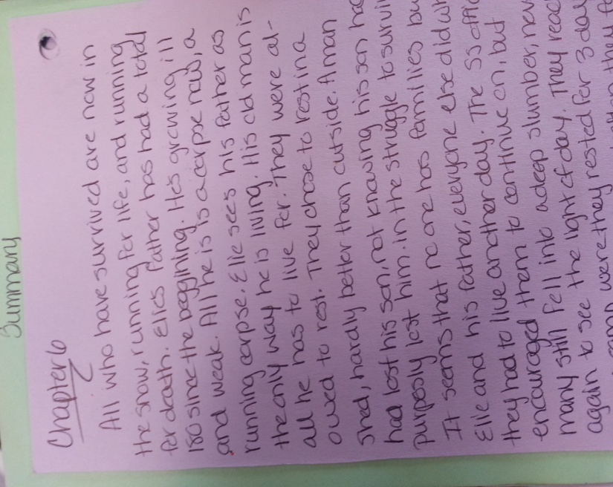
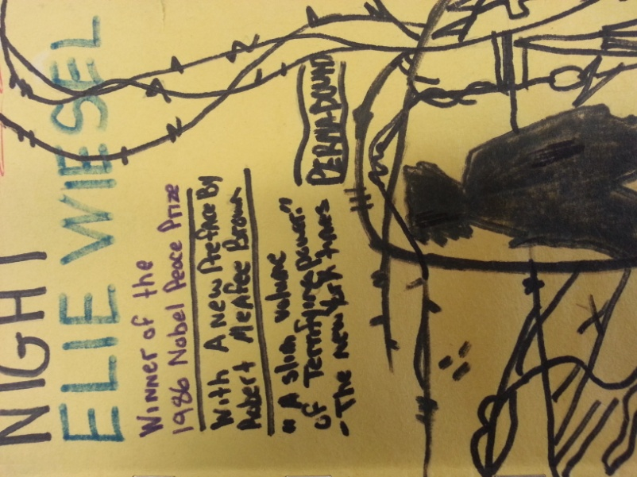
Examples

Date Due:

Occasionally, you will be allowed some time in class to work on your entries, but many will be completed at home. Your logs will be taken up at will. Be sure to keep up with the entries and do not get behind.

