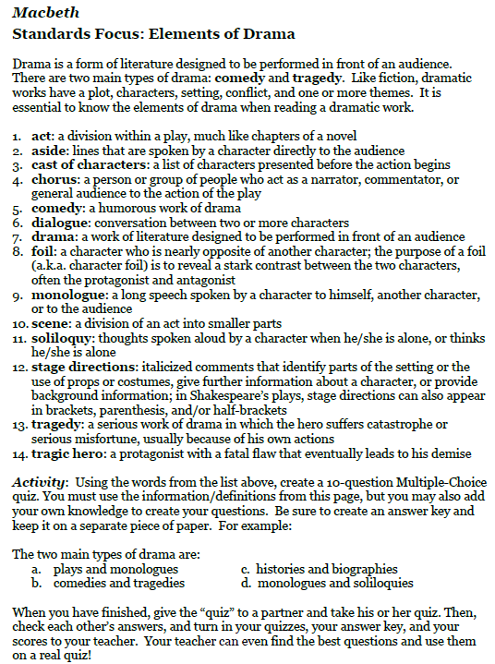

Note – You can type your quiz OR write on notebook paper, but must be submitted to me by Monday.

Note – You can type your quiz OR write on notebook paper, but must be submitted to me by Monday.

