Illustrating the Jew as a devil was also a current theme in Nazi propaganda. Notice the percentage and dollar sign on the “devil Jew” arm.
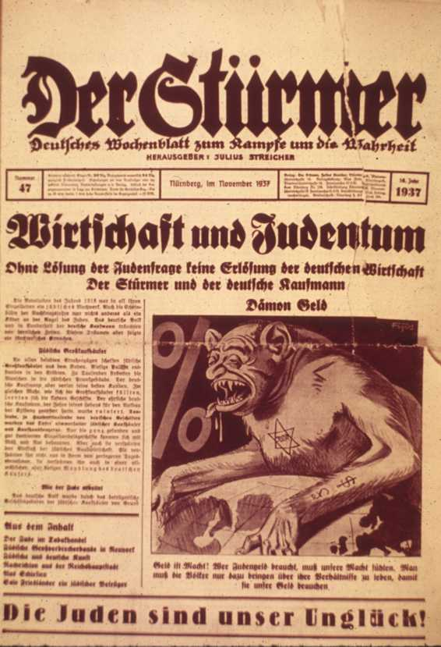
Answer all questions in complete sentences. Have one member to write the answers and one member to present.

- What is the Nazi’s point of view based on this cartoon? (Write at least 5 sentences!)
- The most effective posters use symbols that are unusual, simple, and direct. What symbols (if any) are used in the poster and what do they symbolize?
- Explain why this cartoon is persuasive?
- What does the Nazi Government hope the audience will do as a result of this cartoon?
- What propaganda technique(s) are used in this image?

Daily cost to the state of maintaining one chronically ill person (5.5 marks) could be better spent
supporting an entire healthy German family.

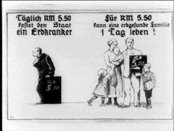

Answer all questions in complete sentences. Have one member to write the answers and one member to present.

- What is the Nazi’s point of view based on this cartoon? (Write at least 5 sentences!)
- The most effective posters use symbols that are unusual, simple, and direct. What symbols (if any) are used in the poster and what do they symbolize?
- Explain why this cartoon is persuasive?
- What does the Nazi Government hope the audience will do as a result of this cartoon?
- What propaganda technique(s) are used in this image?

