This cartoon appeared in the 26th edition of an anti-Semitic weekly newspaper in 1934. It reads, "The Spider. Many victims are trapped in the web, caught by flattering words. Rip the web of deceit and free German youth."
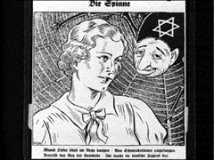
Answer all questions in complete sentences. Have one member to write the answers and one member to present.

- What is the Nazi’s point of view based on this cartoon?
- The most effective posters use symbols that are unusual, simple, and direct. What symbols (if any) are used in the poster and what do they symbolize?
- Explain why this cartoon is persuasive?
- What does the Nazi Government hope the audience will do as a result of this cartoon?
- What propaganda technique(s) are used in this image?

Jews using poison gas was a recurring theme in Nazi anti-Semitic propaganda. In this cartoon, a Nazi suffocates a Jew who sprays poisonous gas over Germany. The caption reads, "Just wait, we'll put a stop to your dirty tricks."

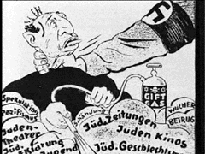
Answer all questions in complete sentences. Have one member to write the answers and one member to present.
- What is the Nazi’s point of view based on this cartoon?
- The most effective posters use symbols that are unusual, simple, and direct. What symbols (if any) are used in the poster and what do they symbolize?
- Explain why this cartoon is persuasive?
- What does the Nazi Government hope the audience will do as a result of this cartoon?
- What propaganda technique(s) are used in this image?
“Behind the enemy powers: the Jews.” Consider who the Allied Powers were.

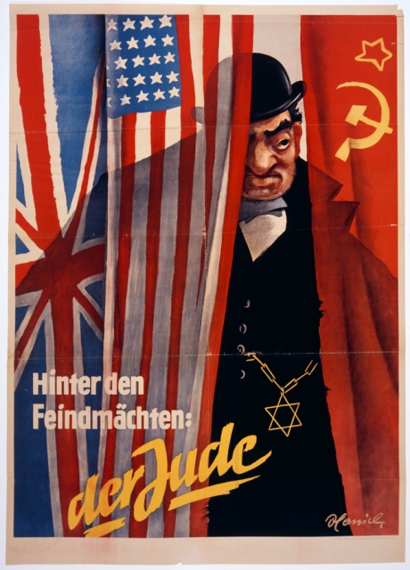

Answer all questions in complete sentences. Have one member to write the answers and one member to present.

- What is the Nazi’s point of view based on this cartoon?
- The most effective posters use symbols that are unusual, simple, and direct. What symbols (if any) are used in the poster and what do they symbolize?
- Explain why this cartoon is persuasive?
- What does the Nazi Government hope the audience will do as a result of this cartoon?
- What propaganda technique(s) are used in this image?

