Name:____________________________________
Date:___________________

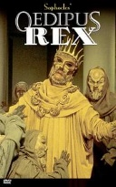
Predictions for Main Characters

Character | Prediction | Quote to Support Prediction
Oedipus  Pg. 231 – 232  Pg. 229  Pg. 226  Pg. 217  Pg. 211-212  Pg. 209 | Based on Oedipus telling Jocasta__________________, I predict that Oedipus will__________________________. | “_______________________.”  This quote shows Oedipus will _____________________ because ________________________.
Jocasta
Pg. 233
Pg. 230
Pg. 228
Creon
Pg. 226 – 227
Pg. 224

