Character Analysis Essay Outline
In preparation for English III and IV, you will write multiple essays analyzing literature. Therefore, it is imperative that you not only take notes and listen in class, but review your notes at home. This Outline is Due Friday, October 13th at the beginning of class. The essay is due Friday October 20th on Turnitin.com
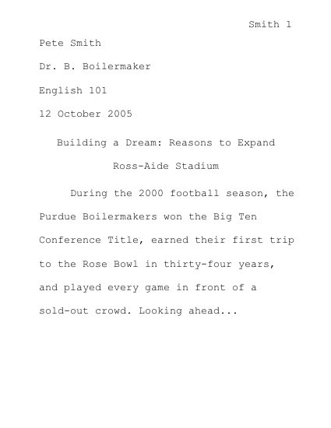
- In your character analysis essay you must analyze Elie Wiesel’s character before and after the Holocaust using his memoir as textual evidence.
Your Character Analysis Essay must consist of the following:
Title page
Essay (3 pages in length)
You must use the following format:
Typed: 12 inch font
1 inch margins

****All essays will count as a test grade. If you need help, I will be available during tutoring on Wednesday to assist you. Please, don’t hesitate to ask!

Below is the thesis statement that you must explain and prove throughout your essay.
Thesis:

Elie Before the Holocaust:
Characterization  (Describe Elie before the Holocaust) | Textual Evidence  (Quote from the book, or scene description; include page number for both) | Explanation  (Explain why the textual evidence accurately describes Elie’s character; connect to thesis)

Describe Elie during and after the Holocaust:
Characterization  (Describe Elie after the Holocaust) | Textual Evidence  (Quote from the book, or scene description; include page number for both) | Explanation  (Explain why the textual evidence accurately describes Elie’s character and how he has changed; connect to thesis)

