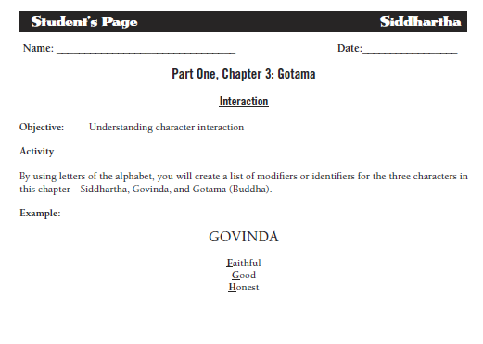

Complete on the long white paper. Due before you leave today, so you will need to read Chs. 2 – 3 and then complete this. Choose ONE of the three characters.