Blackout Poetry Cheat sheet
You will create your own poem using Wiesel’s “Never Shall I Forget”
- Read “Never shall I forget”
- Choose an anchor word from the text (An anchor word is from the text that is very significant (Ex: “Never”)
- Using a pencil, circle words that connect to you and the anchor word
- Review your circled word. That will be your poem. If you are unsatisfied with it, circle other words that can complete your poem, but avoid circling more than 3 words in a row.
- Use a marker and blackout the text that is not circled, thus leaving only the words your circled.
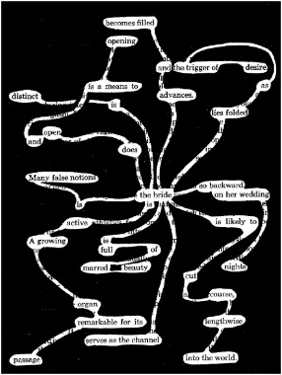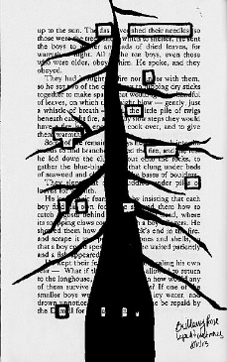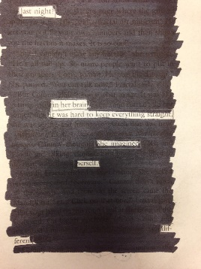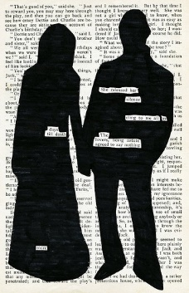

Blackout Poetry Cheat sheet
You will create your own poem using Wiesel’s “Never Shall I Forget”
- Read “Never shall I forget”
- Choose an anchor word from the text (An anchor word is from the text that is very significant (Ex: “Never”)
- Using a pencil, circle words that connect to you and the anchor word
- Review your circled word. That will be your poem. If you are unsatisfied with it, circle other words that can complete your poem, but avoid circling more than 3 words in a row.
- Use a marker and blackout the text that is not circled, thus leaving only the words your circled. You may make in image from the blackout.
