**Advertisement Assignment**

[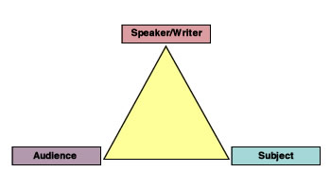](http://www.google.com/url?sa=i&rct=j&q=&esrc=s&frm=1&source=images&cd=&cad=rja&docid=ilSnabmUPuCrSM&tbnid=3K6ZDp3qhgNfSM:&ved=0CAUQjRw&url=http://wac.appstate.edu/wac-glossary-terms/general-writing-terms/d-rhetorical-terms&ei=BU6mUtW1NozmkAfjpoFA&bvm=bv.57752919,d.eW0&psig=AFQjCNGlhmudG-rRqjwjqNp2XyMxUEjUtw&ust=1386716954003813)Task: Your assignment is to create an advertisement for a real or made-up product. The advertisement you create should be appropriate for an ad in a magazine. Your job is to sell the given product using a slogan, descriptions, and an illustration. You must also include at least two of the persuasive techniques we have been studying this week: logos, pathos, and ethos. Be creative and make it colorful!

**Rubric**

Slogan for your product: 10 points

Use of one persuasive technique: 10 points

Use of second persuasive technique: 10 points

Illustration: 10 points

Creativity: 10 points

**Your score will multiplied by 2 for a 100 point quiz grade!**

**Example: A yellow Sharpie highlighter**

Teachers report test scores increase by 50% when using the Sharpie highlighter!

**America’s valedictorians are all using the new Sharpie highlighter! Don’t be left behind!!**

**Don’t miss out on purchasing this year’s newest and most successful highlighter yet!**

[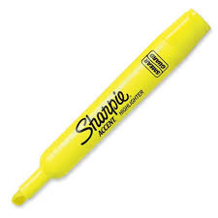](http://www.google.com/url?sa=i&rct=j&q=&esrc=s&frm=1&source=images&cd=&cad=rja&docid=fZ3tOsCEYY8wrM&tbnid=-xlyJfXFvsrDMM:&ved=0CAUQjRw&url=http://jmbattaglia.wordpress.com/tag/reading/&ei=e0mmUoi4MpPnkAfwwIC4Aw&bvm=bv.57752919,d.eW0&psig=AFQjCNGoTiZmf2EawTGyM69If1v_AdMmmQ&ust=1386715882916625)

C:\Users\mobleya\AppData\Local\Microsoft\Windows\Temporary Internet Files\Content.IE5\7BA8Q292\MC900048276[1].wmf